Instructions for BkupSave.cs (Caution: this script has not been thoroughly tested).

1. Copy the enclosed BkupSave.cs & BkupSave.cs.png files to your Vegas Scripting
Directory.
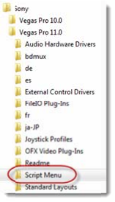
2. Launch Sony Vegas
3. Add the Script to your Toolbar: Options -> Customize Toolbar
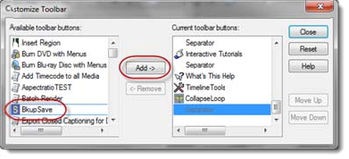
4. You will see the BkupSave icon on your Toolbar
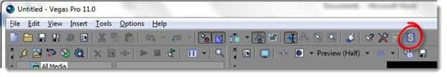
5. Manually open your Vegas Project: File->Open
6. Now, as you work on the project you can click on the BkupSave icon and the script will save your project and a backup (with a datetime stamp).
7. As you work on your project, continue to use the BkupSave Script at good backup
points.
8. If you ever need to restore the project, open the appropriate backup in your project folder.
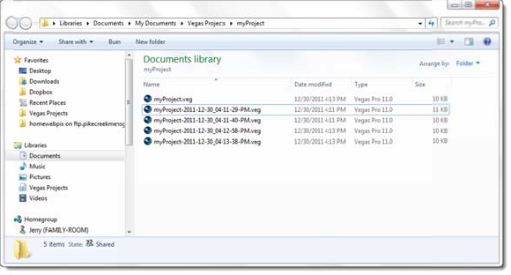

9. Jerry am Ende, alal19808@yahoo.com

